FIRE ALARM MONITORING SERVICES
TEST MODE
To disable communication to DFES Communication Centre

Step 1: Place the iButton onto the reader for 3-4 Step 2: Display will show Testmode seconds. 240m
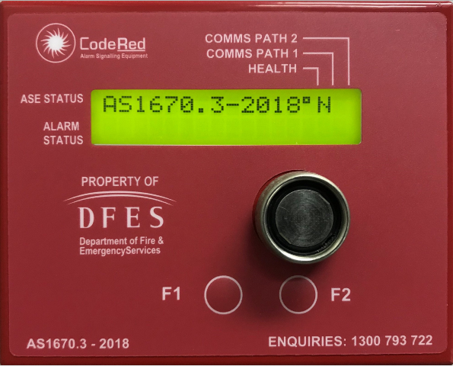
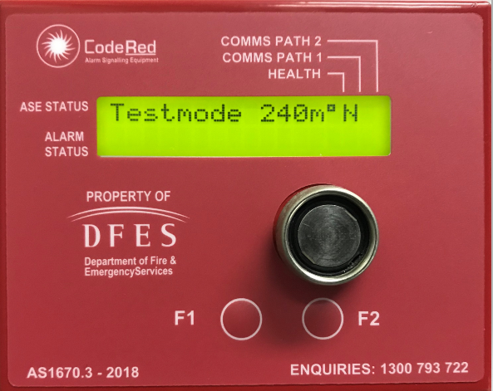

The ASE will automatically exit Test Mode 4 hours after entering Test mode, unless manually returned to normal mode ‘AS1670.3-2018’

F1 – Not in Use
Comms Path 2 – Not in Use

RETURNING THE ASE BACK TO NORMAL MODE
To enable communication with DFES Communication Centre

- Reset all Alarms on the Fire Indicator Panel (FIP).
- Press the F2 button for 1-2 seconds on the ASE to clear “ALARM STATUS” Alarms that are in the ASE memory.
- Place the iButton on the reader for 3-4 seconds to change the ASE from the Test Mode to the Normal Mode "AS1670.3-2018".

Removing the ASE from the Test Mode with active Alarms will call the Fire Brigade!

FOR ASSISTANCE PLEASE CONTACT
FIRE ALARM MONITORING SERVICES 24/7 ON:
1300 793 722

